**Bike Store Sales and Operational Analysis Report**  
*Strategic Recommendations for Post-2018 Recovery and Growth*

**Executive Summary**

Following the complete halt in operations in 2018 due to supply shortages, the bike store is now focused on regaining market presence, rebuilding trust, and driving long-term profitability. This report outlines a reentry strategy guided by data from before the disruption, analyzing sales trends, customer behavior, and operational performance to inform targeted actions for sustainable growth.

**1. Strategic Reentry After 2018 Disruption**

The 2018 operational crash, triggered by an unexpected and extended supply chain breakdown, left a significant gap in customer trust and market consistency. A thoughtful and data-driven reentry is necessary to restore confidence and profitability.

**Reestablishing Market Presence**

* **Customer Communication:** Launch targeted email campaigns and digital ads to inform previous customers that full operations have resumed.
* **Product Line Refresh:** Introduce electric and eco-friendly bikes in response to shifting market trends and growing environmental consciousness.
* **Promotional Incentives:** Offer relaunch deals and bundled discounts to encourage return purchases and attract new customers.

**Operational Strengthening**

* **Resilient Supply Chains:** Secure diversified supplier relationships to prevent single points of failure like in 2018.
* **Smarter Inventory Systems:** Implement predictive restocking based on historical demand patterns to avoid stockouts.
* **Improved Fulfillment:** Partner with reliable logistics providers to ensure timely deliveries and service recovery.

**Brand Rebuilding and Engagement**

* **Transparency:** Acknowledge the 2018 challenges and highlight changes made to prevent recurrence.
* **Influencer & Community Marketing:** Partner with local cycling groups and online personalities to amplify visibility and credibility.
* **Customer Support:** Enhance service channels to provide faster, more responsive pre-sale and post-sale support.

**2. Learning from the Past: Insights to Guide Reentry**

To support this reentry, we turn to key data and insights from before the disruption to understand what was working, what wasn’t, and how to build a stronger business model.

**Sales Performance and Product Demand**

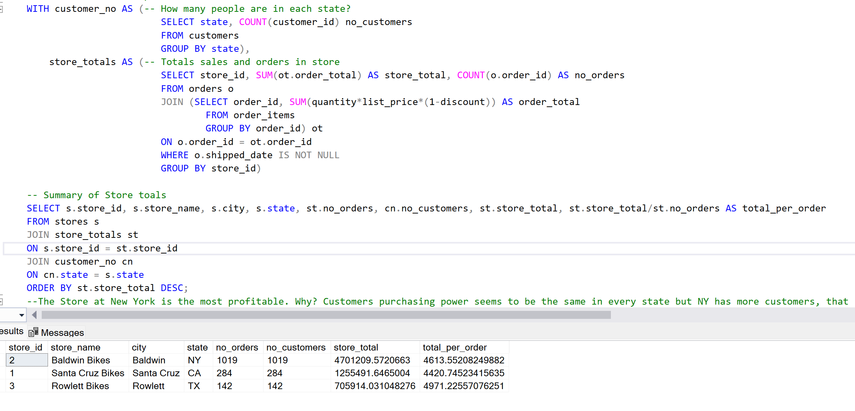

Figure 1:Profitability of stores

Before 2018, revenue growth was strongly tied to customer density. The New York store, as seen in Figure 1, located in a high-footfall area, led in profitability. This highlights the importance of:

* **Location-Specific Strategies:** Invest more in stores with high traffic and affluent demographics.
* **Targeting High-Value Customers:** Focus pricing and products on middle and upper-middle-class consumers, who drove most sales.
* **Bundled Promotions:** Use product pairings and discounts to increase transaction value, a tactic that worked well in the past.

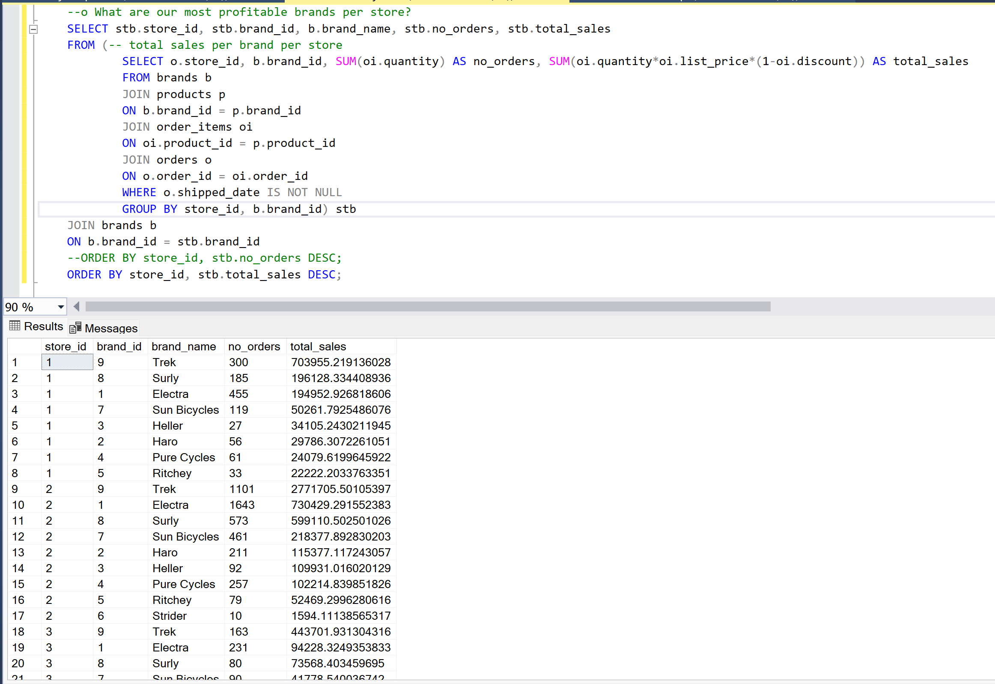

Figure 2:Brand Profitability

Popular brands, as shown in Figure 2—**Trek**, **Surly**, and **Electra**—consistently performed well across all regions. Moreover, **electric bikes** were emerging as a customer favorite.

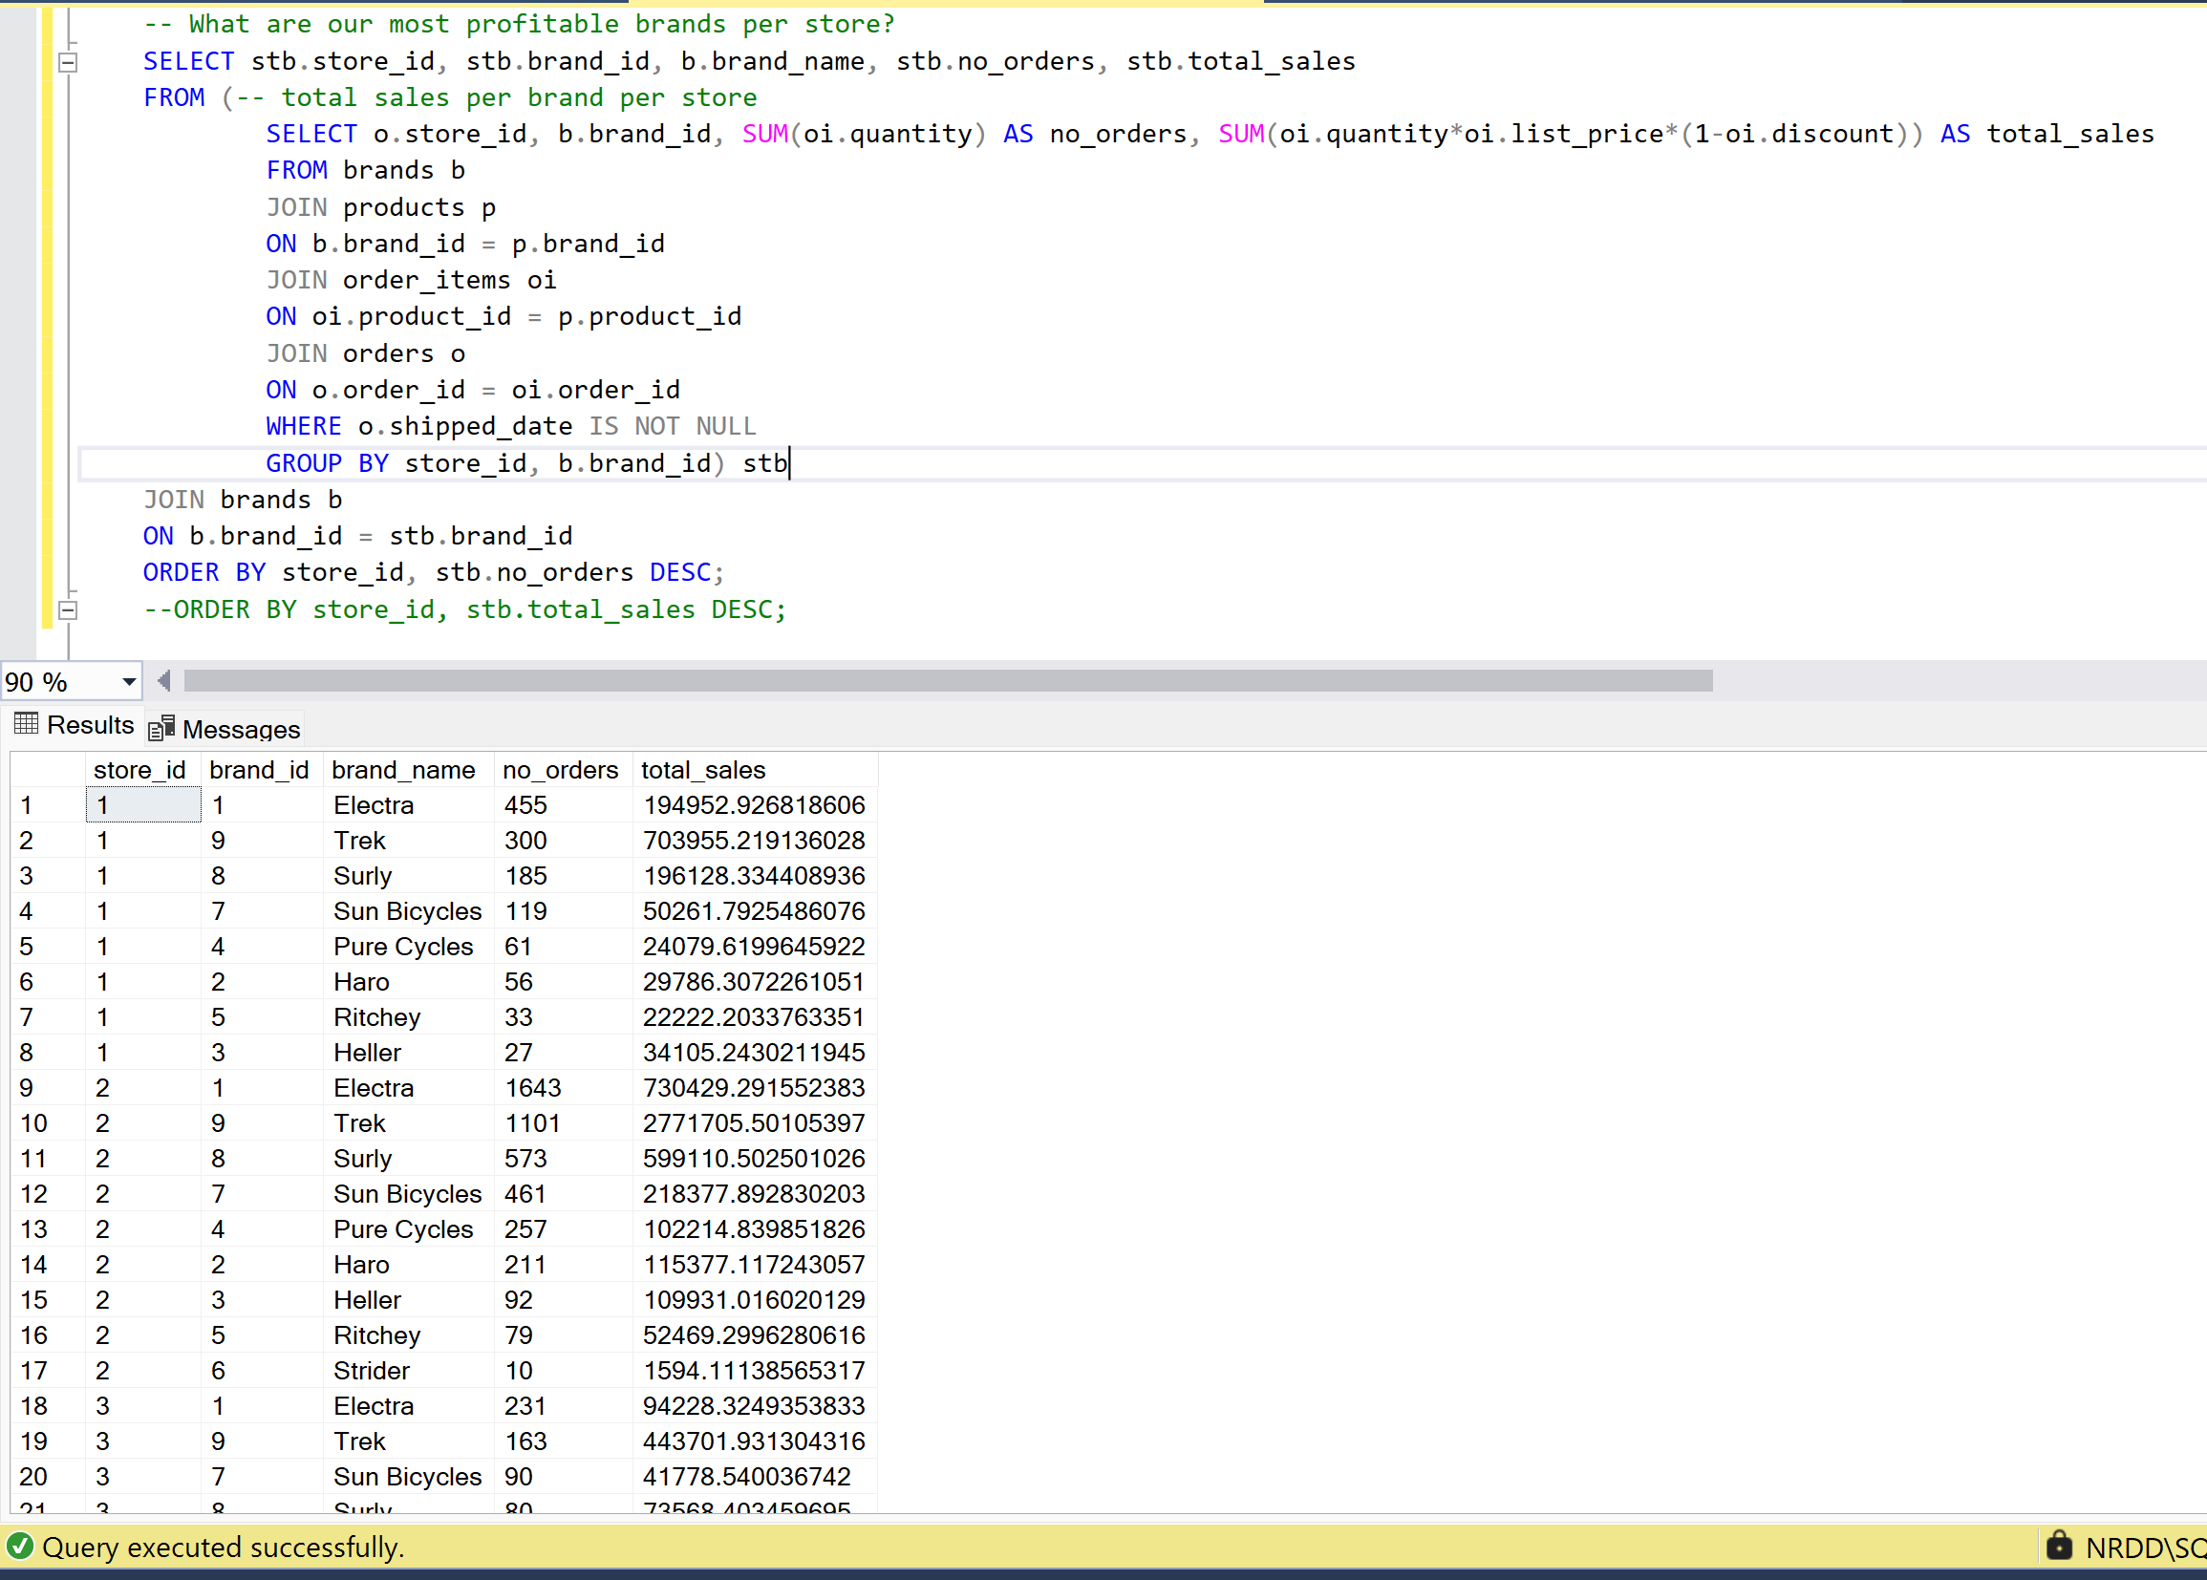

Figure 3: Brand Popularity

* **Tailored Inventory by Location:** Stock stores with region-specific preferences and prioritize top-selling models as highlighted by Figure 3. For example, filling New York with more Trek bikes.
* **Expansion of Electric Models:** Double down on this growing category to stay aligned with modern mobility trends.

**3. Operational and Staffing Insights**

Operational challenges weren’t limited to inventory. Staff data shown in Figure 4 revealed imbalances as well:

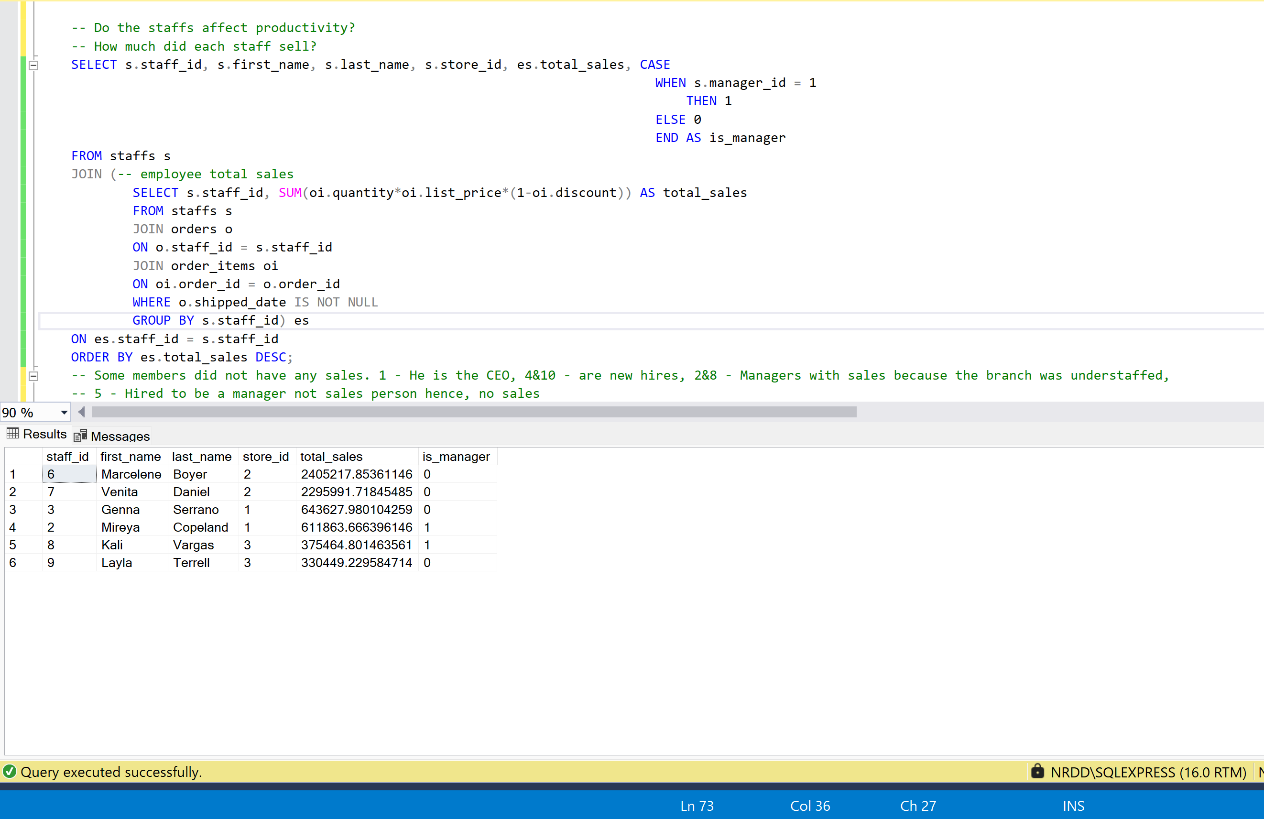

Figure 4: Staff Sales Record

* **Managerial Flexibility:** During shortages and understaffing, some managers stepped into sales roles. These contributions should be formally recognized.
* **Staff Incentives:** To foster a performance-driven culture, implement bonuses, sales commissions, and recognition programs.

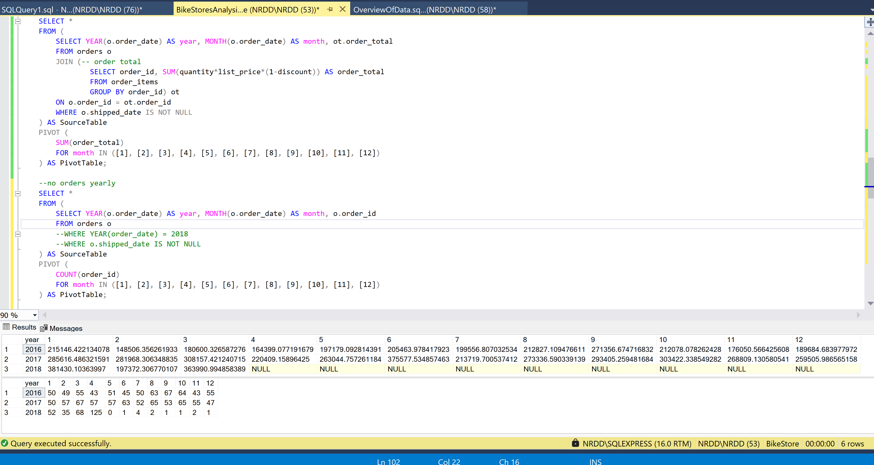

Figure 5: Total Sales & Total Orders Yearly Breakdown

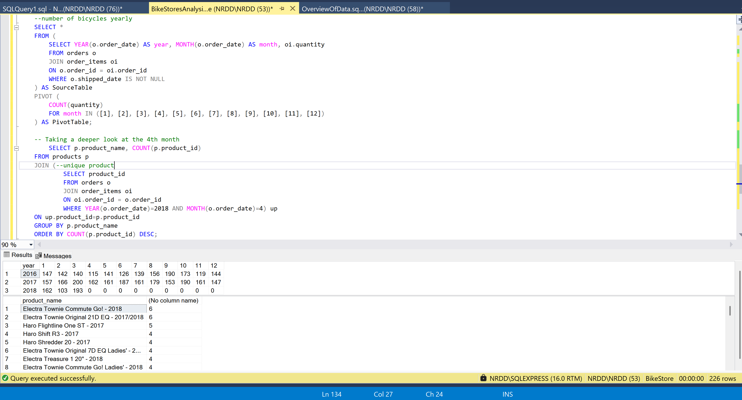

Figure 6: Total Quantity Yearly Breakdown & Product Breakdown (for April 2018)

It’s important to note that the 2018 sales crash was not the result of poor catalog alignment with customer needs, as noted in Figure 6, but rather due to severe inventory shortages caused by supply chain disruptions. Demand remained strong—our inability to fulfill orders was the core issue. This period also demonstrated the consequences of insufficient inventory forecasting, highlighted in Figure 5. Despite a continued stream of customer orders in 2018, sales dropped to zero because the business couldn't fulfill them.

* **Demand Forecasting Tools:** Implement analytics-based forecasting to anticipate high-demand periods.
* **Supplier Agreements:** Negotiate stronger terms with manufacturers to secure priority restocking in peak seasons.

**4. Marketing and Customer Loyalty**

With the business now reentering the market, customer engagement will be key.

* **Social Media Revival:** Use platforms like Instagram and Facebook to rebuild awareness, share success stories, and promote new arrivals.
* **Loyalty Programs:** Reward returning customers with points, discounts, or exclusive access to new products.
* **Personalized Marketing:** Leverage purchase history to offer targeted recommendations that drive repeat business.
* **Customer Reviews:** Encourage satisfied buyers to share feedback, while actively responding to concerns to show transparency and care.

Demographic targeting will also be essential. Pre-2018 data shows that middle and upper-middle-income customers were the primary buyers. Reentry marketing should therefore focus on regions and platforms where this demographic is most active.

**Conclusion**

The 2018 operational breakdown was a pivotal moment for the bike store. Now, with operations resuming, there is a rare opportunity to rebuild stronger, smarter, and more connected to the customer. By learning from past data—understanding what drove sales, where operational gaps existed, and how customers behaved—the store can position itself not just for recovery, but for long-term leadership in the market.